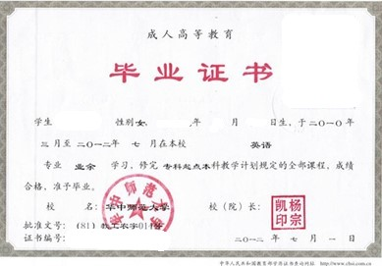

CERTIFICATE OF ADULT HIGHER EDUCATION GRADUATION

**Certificate No.** XXXXXXX

This is to certify that **XXX,** female, born on **March 12, XXXX**, has studied from **March 2010** to **July 2012**, majoring in **English**. She has completed all the courses prescribed in the Teaching Program and satisfied the requirements of the **3** year **full-time/night school /correspondence/starting from an associate degree** undergraduate program and is hereby granted graduation from **Central China Normal University**.

**Yang Zongkai**

President

**Central China Normal University**

**Date of Issue:** July 1, 2012